Nunit Tests on Visual Studio Code

Open Visual Studio Code, and go to your crowsoftmvcworkspace.

Go to terminal, go back one folder to the Project root, then make a new directory, mkdir crowsoft_unittest

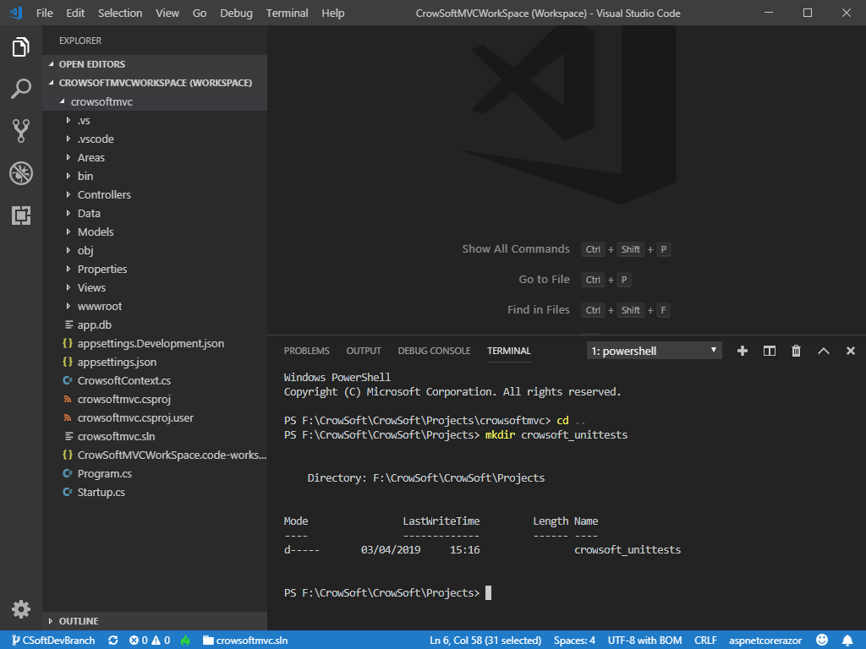

Go into the new directory by using cd

Type ***dotnet new nunit***, and press enter. Note: This will create the project structure for your nunit tests.

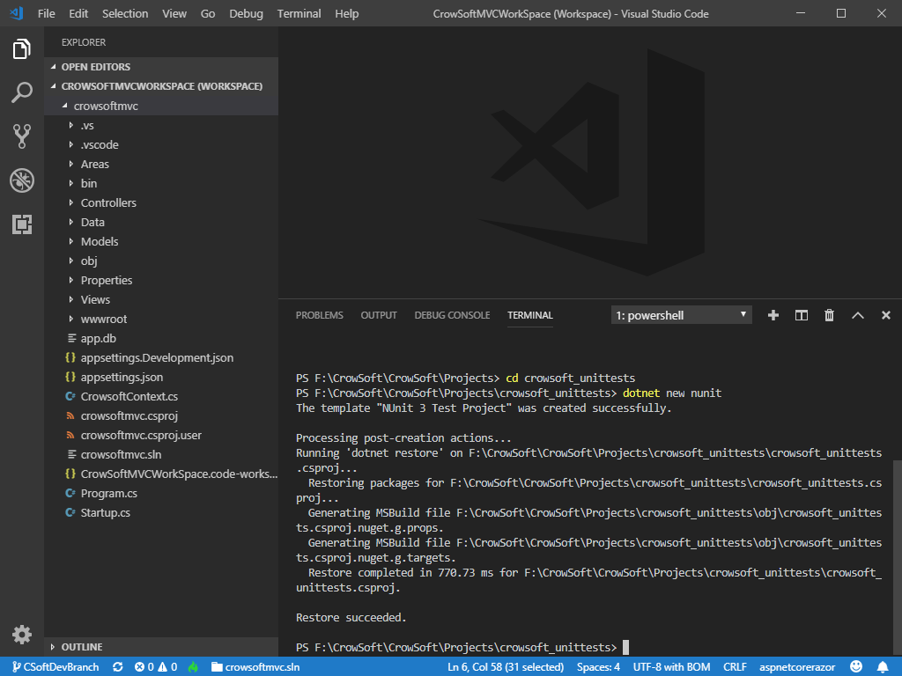

Right click on the open space below the code, then click Add Folder to Workspace.

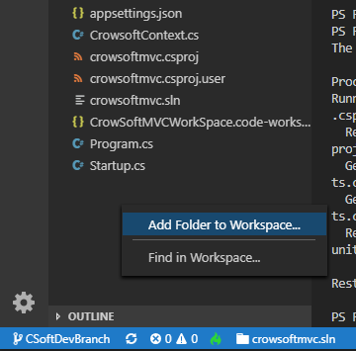

Select your folder, crowsoft_unittests, and click Add

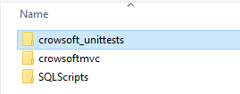

You can see below, crowsoft_unittests folder added to your workspace.

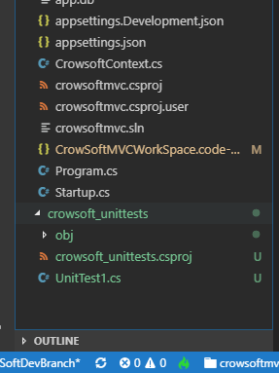

Now we need to reference of our main project to the unit test project.

Open Terminal, and type in the following code and press enter: dotnet add reference ../crowsoftmvc/crowsoftmvc.csproj 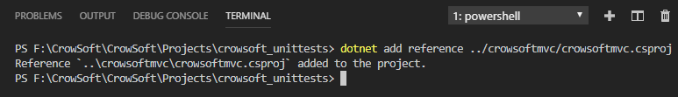

Now the crowsoftmvc.proj is added to the unittests project.

For the unit test to work, I moved and renamed CrowsoftContext to the Data folder and called it DummyContext. The reason for that is because the context is specific to the Dummy table.

Here is the change below:

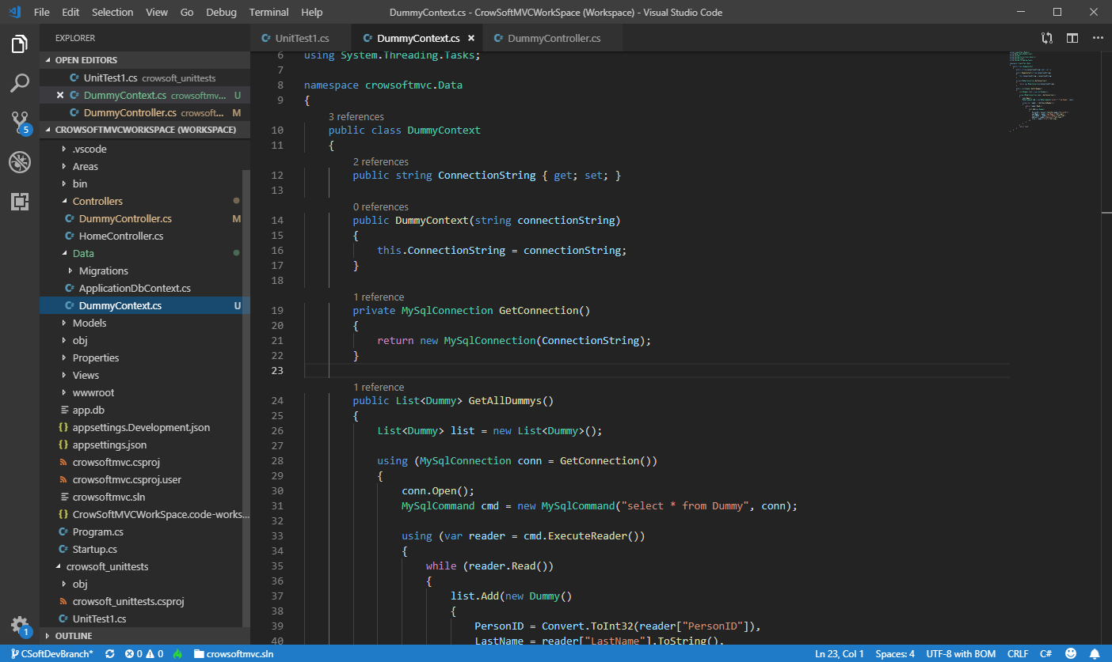

Include the following Package References to your crowsoft_unittests.csproj file.

<PackageReference Include="Microsoft.AspNetCore.Mvc.Core" Version="2.2.2" />

<PackageReference Include="Microsoft.AspNetCore.Razor.Design" Version="2.2.0" />

<PackageReference Include="Microsoft.AspNetCore.TestHost" Version="2.2.0" />

<PackageReference Include="Microsoft.EntityFrameworkCore.Sqlite" Version="2.2.3" />

<PackageReference Include="Microsoft.Extensions.Configuration" Version="2.2.0" />

<PackageReference Include="Microsoft.Extensions.Configuration.Json" Version="2.2.0" />

<PackageReference Include="Microsoft.VisualStudio.Web.CodeGeneration.Design" Version="2.2.3" />

<PackageReference Include="Moq" Version="4.10.1" />

<PackageReference Include="MySql.Data" Version="8.0.15" />

Add a appconfig.json file. This is to reference the connection string for MySQL.

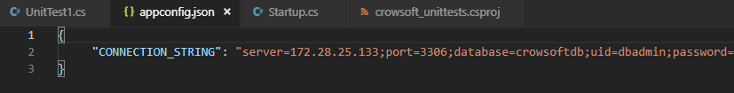

Open UnitTest1.cs, and added connection string code to setup a connection string for all tests.

First, read the appconfig.json file into a variable called config.

var config = new ConfigurationBuilder()

.AddJsonFile("appconfig.json")

.Build();

Then, read the connectionstring into a local variable, called connection_string. 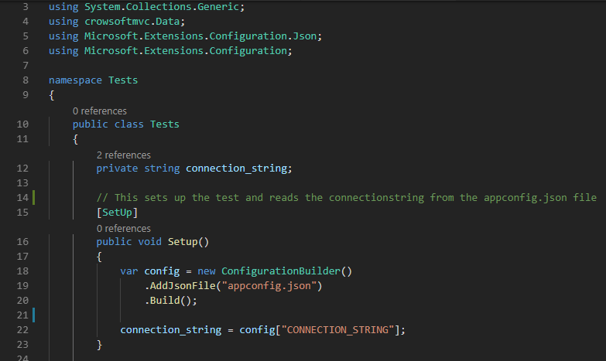

Make sure the following using statements are added:

using System.Collections.Generic;

using crowsoftmvc.Data;

using Microsoft.Extensions.Configuration.Json;

using Microsoft.Extensions.Configuration;

Add a new method to test if Dummy records are returned. It should return 2 record, which are Greater than 0.

// This is a example test, that test if Dummy records are available in the MySQL Database

[Test]

public void Test_GetDummyList()

{

DummyContext context = new DummyContext(connection_string);

List<crowsoftmvc.Models.Dummy> myDummyList = context.GetAllDummys();

Assert.Greater(myDummyList.Count, 0, "Error No Dummy Records Returned");

}

Go to crowsoft_unittests.csproj and add the following into the ItemGroup:

<None Update="appconfig.json">

<CopyToOutputDirectory>Always</CopyToOutputDirectory>

</None>

Example:

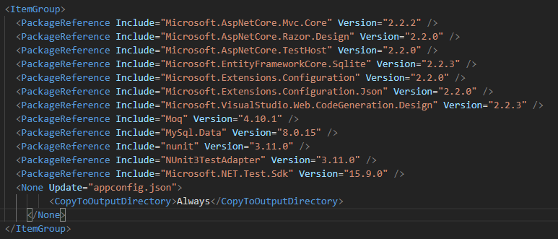

Open Terminal for crowsoft_unittests, and type in dotnet test

You should get the following results:

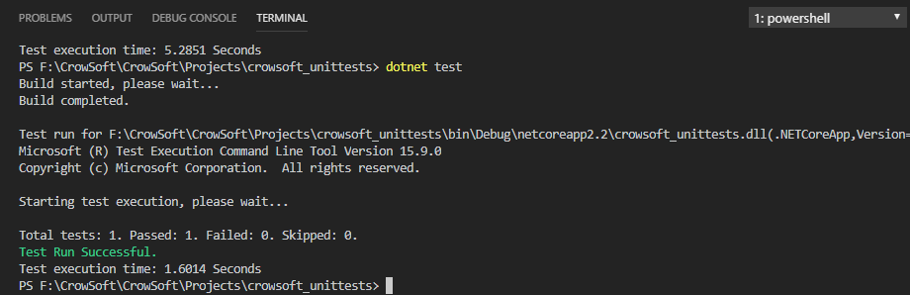

Finish..